实验报告：

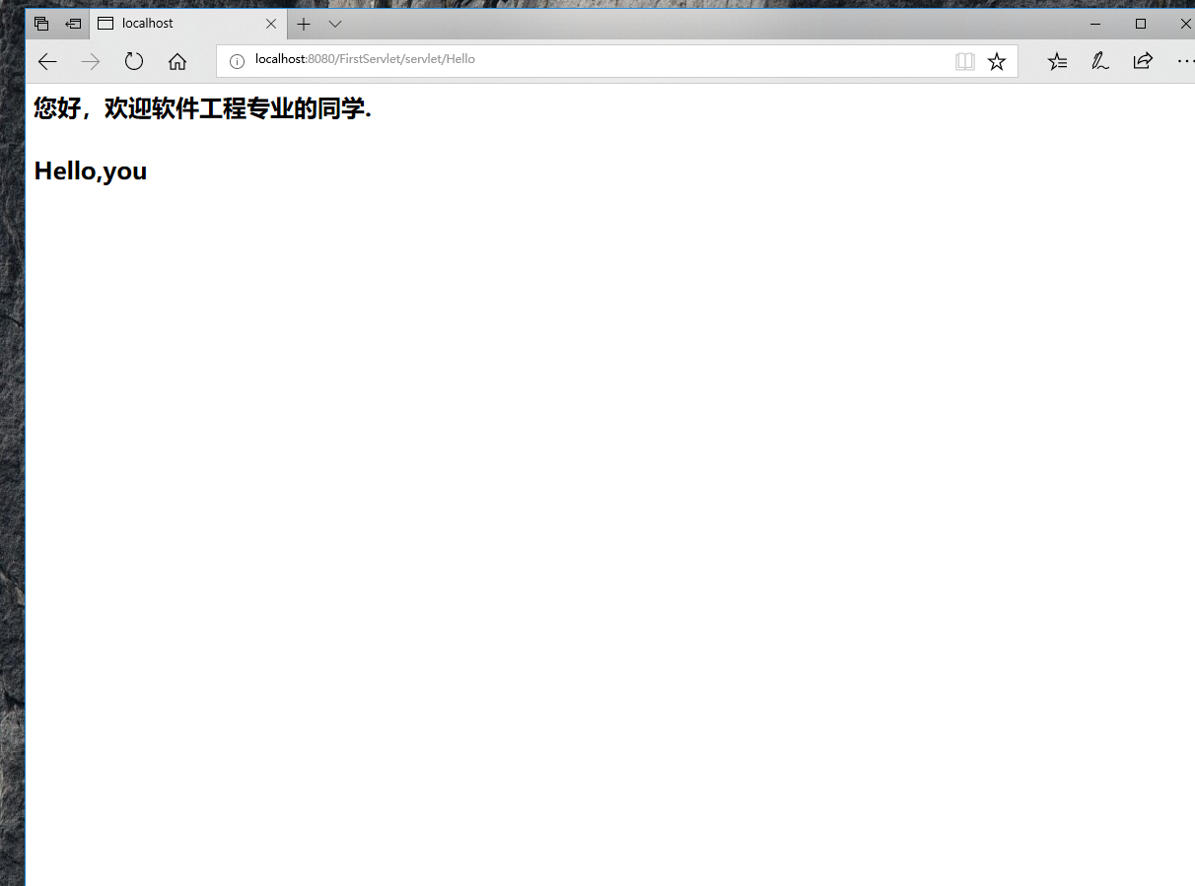

package cc.openhome;

import java.io.IOException;

import java.io.PrintWriter;

import javax.servlet.ServletException;

import javax.servlet.annotation.WebServlet;

import javax.servlet.http.HttpServlet;

import javax.servlet.http.HttpServletRequest;

import javax.servlet.http.HttpServletResponse;

//@WebServlet(name="Hello",urlPatterns={"/test2/hello.view"})

public class Hello extends HttpServlet {

public void doGet(HttpServletRequest request, HttpServletResponse response)

throws ServletException, IOException {

response.setContentType("text/html;charset=GBK");

PrintWriter out = response.getWriter();

out.println("<html><html>");

out.println("<h2>您好，欢迎软件工程专业的同学.<br><br>Hello,you</h2>");

out.println(" </body></html>");

}

public void doPost(HttpServletRequest request, HttpServletResponse response)

throws ServletException, IOException {

doGet(request,response);

}

}

2注释法

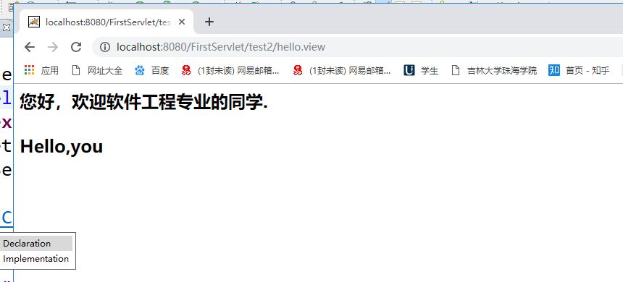

package cc.openhome;

import java.io.IOException;

import java.io.PrintWriter;

import javax.servlet.ServletException;

import javax.servlet.annotation.WebServlet;

import javax.servlet.http.HttpServlet;

import javax.servlet.http.HttpServletRequest;

import javax.servlet.http.HttpServletResponse;

@WebServlet(name="Hello",urlPatterns={"/test2/hello.view"})

public class Hello extends HttpServlet {

public void doGet(HttpServletRequest request, HttpServletResponse response)

throws ServletException, IOException {

response.setContentType("text/html;charset=GBK");

PrintWriter out = response.getWriter();

out.println("<html><html>");

out.println("<h2>您好，欢迎软件工程专业的同学.<br><br>Hello,you</h2>");

out.println(" </body></html>");

}

public void doPost(HttpServletRequest request, HttpServletResponse response)

throws ServletException, IOException {

doGet(request,response);

}

}

3文件配置法

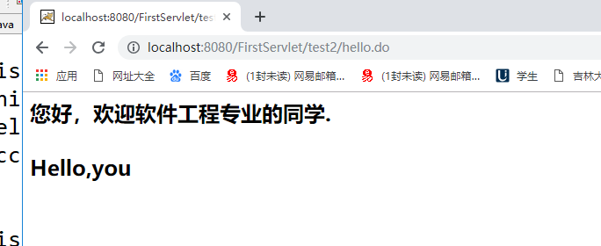

<?xml version=*"1.0"* encoding=*"UTF-8"*?>

<web-app version=*"3.0"*

xmlns=*"http://java.sun.com/xml/ns/javaee"*

xmlns:xsi=*"http://www.w3.org/2001/XMLSchema-instance"*

xsi:schemaLocation=*"http://java.sun.com/xml/ns/javaee*

*http://java.sun.com/xml/ns/javaee/web-app_3_0.xsd"*>

<display-name></display-name>

<servlet>

<description>This is the description of my J2EE component</description>

<display-name>This is the display name of my J2EE component</display-name>

<servlet-name>HelloServlet</servlet-name>

<servlet-class>cc.openhome.HelloServlet</servlet-class>

</servlet>

<servlet>

<description>This is the description of my J2EE component</description>

<display-name>This is the display name of my J2EE component</display-name>

<servlet-name>Hello</servlet-name>

<servlet-class>cc.openhome.Hello</servlet-class>

</servlet>

<servlet-mapping>

<servlet-name>Hello</servlet-name>

<url-pattern>/test2/hello.view</url-pattern>

</servlet-mapping>

<servlet-mapping>

<servlet-name>Hello</servlet-name>

<url-pattern>/servlet/Hello</url-pattern>

</servlet-mapping>

<welcome-file-list>

<welcome-file>index.jsp</welcome-file>

</welcome-file-list>

</web-app>

2大题

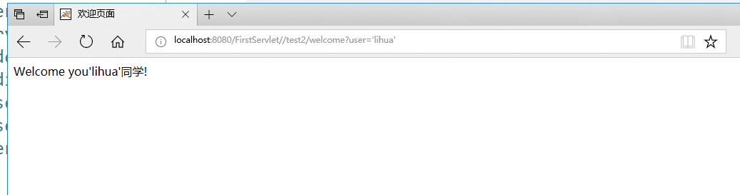

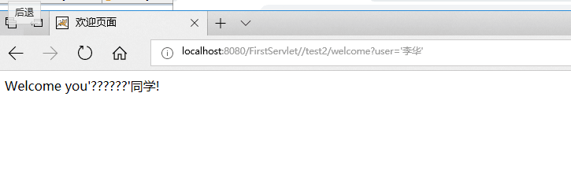

第25行是创建一个遍量 可以进行赋值。

图中李华变成？？？应该是不支持中文导致的

package cc.openhome;

import java.io.IOException;

import java.io.PrintWriter;

import javax.servlet.ServletException;

import javax.servlet.http.HttpServlet;

import javax.servlet.http.HttpServletRequest;

import javax.servlet.http.HttpServletResponse;

//@WebServlet(name="Hello",urlPatterns={"/test2/welcome"})

public class WelcomeYou extends HttpServlet {

/**

*

*/

private static final long serialVersionUID = 1L;

/**

* The doGet method of the servlet. <br>

*

* This method is called when a form has its tag value method equals to get.

*

* @param request the request send by the client to the server

* @param response the response send by the server to the client

* @throws ServletException if an error occurred

* @throws IOException if an error occurred

*/

public void doGet(HttpServletRequest request, HttpServletResponse response)

throws ServletException, IOException {

String user=request.getParameter("user");

String welcomeInfo="Welcome you"+user+"同学!";

response.setContentType("text/html;charset=GBK");

PrintWriter out = response.getWriter();

//out.println("<!DOCTYPE HTML PUBLIC \"-//W3C//DTD HTML 4.01 Transitional//EN\">");

out.println("<HTML>");

out.println(" <HEAD><TITLE>欢迎页面</TITLE></HEAD>");

out.println(" <BODY>");

out.print(welcomeInfo);

//out.print(this.getClass());

//out.println(", using the GET method");

out.println(" </BODY>");

out.println("</HTML>");

out.flush();

out.close();

}

}

3大题

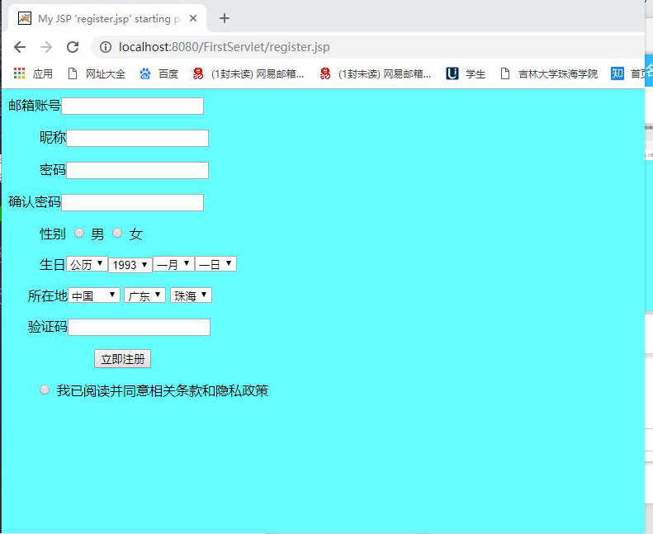

<%@ page language=*"java"* import=*"java.util.*"* pageEncoding=*"utf-8"*%>

<%

String path = request.getContextPath();

String basePath = request.getScheme()+"://"+request.getServerName()+":"+request.getServerPort()+path+"/";

%>

<!DOCTYPE HTML PUBLIC "-//W3C//DTD HTML 4.01 Transitional//EN">

<html>

<head>

<base href=*"*<%=basePath%>*"*>

<title>My JSP 'register.jsp' starting page</title>

<meta http-equiv=*"pragma"* content=*"no-cache"*>

<meta http-equiv=*"cache-control"* content=*"no-cache"*>

<meta http-equiv=*"expires"* content=*"0"*>

<meta http-equiv=*"keywords"* content=*"keyword1,keyword2,keyword3"*>

<meta http-equiv=*"description"* content=*"This is my page"*>

<!--

<link rel="stylesheet" type="text/css" href="styles.css">

-->

</head>

<body bgcolor=*"#66FFFF"*>

<form action=*"success.jsp"* method=*"post"*>

<p><label>邮箱账号</label><input name=*"account"* type=*"text"* /></p>

<p><label >&nbsp;&nbsp;&nbsp;&nbsp;&nbsp;&nbsp;&nbsp;&nbsp;昵称</label><input name=*"name"* type=*"text"* /></p>

<p><label>&nbsp;&nbsp;&nbsp;&nbsp;&nbsp;&nbsp;&nbsp;&nbsp;密码</label><input name=*"password"* type=*"text"* /></p>

<p><label>确认密码</label><input name=*"passwords"* type=*"text"* /></p>

<p><label>&nbsp;&nbsp;&nbsp;&nbsp;&nbsp;&nbsp;&nbsp;&nbsp;性别</label>

<label>

<input type=*"radio"* name=*"sex"* value=*"man"* id=*"sex_0"* />

男</label>

<label>

<input type=*"radio"* name=*"sex"* value=*"woman"* id=*"sex_1"* />

女</label>

<br />

</p>

<p><label>&nbsp;&nbsp;&nbsp;&nbsp;&nbsp;&nbsp;&nbsp;&nbsp;生日<select name=*"birth"*>

<option value=*"lunar"*>公历</option>

<option value=*"new"*>农历</option>

</select><select name=*"date"*><option value=*"one"*>1993</option>

<option value=*"two"*>1996</option></select><select name=*"month"*>

<option value=*"name1"*>一月</option>

<option value=*"name2"*>二月</option>

</select><select name=*"day"*><option value=*"name3"*>一日</option>

<option value=*"name4"*>二日</option></select></label></p>

<p><label>&nbsp;&nbsp;&nbsp;&nbsp;&nbsp;所在地</label><select name=*"place"*></p>

<option value=*"place1"*>中国</option>

<option value=*"place2"*>俄罗斯</option></select>

<select name=*"place"*></p>

<option value=*"place1"*>广东</option>

<option value=*"place2"*>湖南</option></select>

<select name=*"place"*></p>

<option value=*"place1"*>珠海</option>

<option value=*"place2"*>长沙</option></select>

<p><label>&nbsp;&nbsp;&nbsp;&nbsp;&nbsp;验证码</label><input name=*"ensure"* type=*"text"* /></p>

<p>&nbsp;&nbsp;&nbsp;&nbsp;&nbsp; &nbsp;&nbsp;&nbsp;&nbsp;&nbsp;&nbsp;&nbsp;&nbsp;&nbsp;&nbsp;&nbsp;&nbsp;&nbsp; &nbsp;&nbsp;<input name=*"register"* type=*"submit"* value=*"立即注册"* /></p>

<p>&nbsp;&nbsp;&nbsp;&nbsp;&nbsp;&nbsp; <input type=*"radio"* name=*"sex"* value=*"agress"* id=*"sex_2"* />

我已阅读并同意相关条款和隐私政策</label> </p>

<p></p>

<p></p>

<p></p>

<p></p>

</form>

</body>

</html>

<%@ page contentType=*"text/html;charset=utf-8"* %>

<%response.setCharacterEncoding("utf-8");

response.setHeader("iso-8859-1","utf-8");

request.setCharacterEncoding("utf-8");

String name = request.getParameter("name");

String psd = request.getParameter("password");

**if**(name.equals("")||psd.equals("")){

response.setHeader("Refresh","1;url=fail.jsp");

**return**;

}

**else**{

String acc=request.getParameter("account");

String yourName=request.getParameter("name");

out.println("<HTML><BODY><Font size=8><P>注册成功！你的邮箱账号为");

out.println(acc);

out.println("</P><BR>SUCCESS</BR></FONT></BODY></HTML>");

}

%>

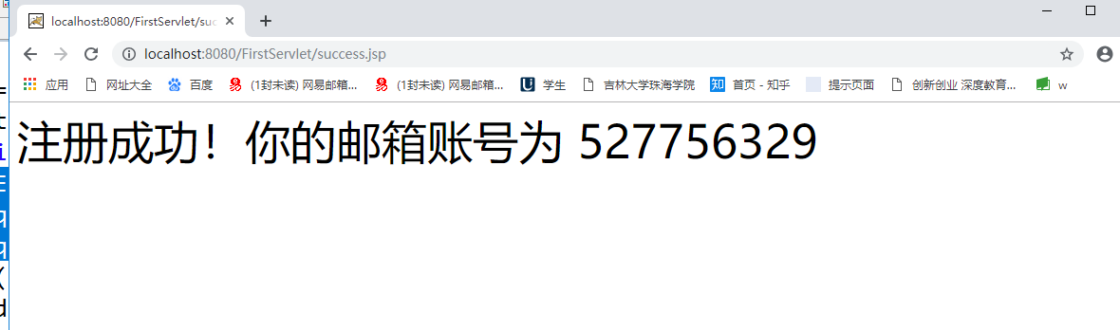

<%@ page contentType=*"text/html;charset=utf-8"* %>

<%response.setCharacterEncoding("utf-8");

response.setHeader("iso-8859-1","utf-8");

request.setCharacterEncoding("utf-8");

String name = request.getParameter("name");

String psd = request.getParameter("password");

**if**(name.equals("")||psd.equals("")){

response.setHeader("Refresh","1;url=fail.jsp");

**return**;

}

**else**{

String acc=request.getParameter("account");

String yourName=request.getParameter("name");

out.println("<HTML><BODY><Font size=8><P>注册成功！你的邮箱账号为");

out.println(acc);

out.println("</P><BR></BR></FONT></BODY></HTML>");

}

%>

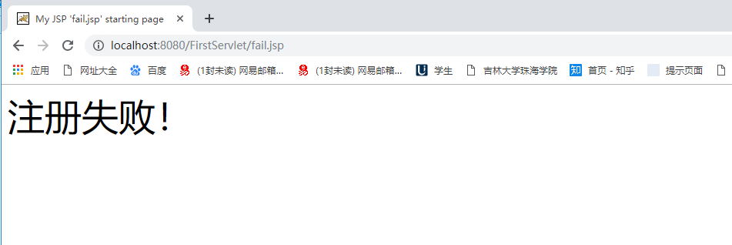

<%@ page language=*"java"* import=*"java.util.*"* pageEncoding=*"utf-8"*%>

<%

String path = request.getContextPath();

String basePath = request.getScheme()+"://"+request.getServerName()+":"+request.getServerPort()+path+"/";

%>

<!DOCTYPE HTML PUBLIC "-//W3C//DTD HTML 4.01 Transitional//EN">

<html>

<head>

<base href=*"*<%=basePath%>*"*>

<title>My JSP 'fail.jsp' starting page</title>

<meta http-equiv=*"pragma"* content=*"no-cache"*>

<meta http-equiv=*"cache-control"* content=*"no-cache"*>

<meta http-equiv=*"expires"* content=*"0"*>

<meta http-equiv=*"keywords"* content=*"keyword1,keyword2,keyword3"*>

<meta http-equiv=*"description"* content=*"This is my page"*>

<!--

<link rel="stylesheet" type="text/css" href="styles.css">

-->

</head>

<body>

<Font size=*8*><P>注册失败！</P>

<BR></BR></FONT></BODY></HTML><br>

</body>

</html>